North American Butterfly Association – Miami Blue Chapter
Serving Dade and Monroe Counties
PO Box 141667
Coral Gables, FL 33114
Email: MiamiBlueChapter@bellsouth.net

October 6, 2009

Big Cypress National Preserve
Addition General Management Plan
National Park Service
Denver Service Center – Planning
P.O. Box 25287
Denver, Co 80225

RE: BIG CYPRESS NATIONAL PRESERVE – ADDITION, DRAFT GENERAL MANAGEMENT PLAN/WILDERNESS STUDY, OFF-ROAD VEHICLE MANAGEMENT PLAN/ENVIRONMENTAL IMPACT STATEMENT (collectively, the “DRAFT PLAN”)
Dear Mss/Sirs:

This letter comes on behalf of the North American Butterfly Association NABA) - Miami Blue Chapter, in support of the draft plan’s Alternative F. Butterflies are a visible element of the wildlife of the Big Cypress Preserve (an attached list of species may be of interest to you). Like all wildlife, habitat integrity is essential for butterfly presence and reproduction. Nationally, butterflying is emerging as a passive recreation, rivaling birding, with observation and photography (as opposed to collecting) the focus of NABA. In South Florida, where butterflies occur year-round, they attract increasing numbers of visitors and are the focus of increasing numbers of naturalist programs and wildlife tourism.

We judge that Alternative F is is the environmentally sustainable alternative. A side-by-side comparison of Alternative F with what has been designated as the “preferred alternative” is attached. This was made available to us by the Tropical Audubon Society of Miami. The comparison speaks for itself.

Butterfly habitat is plant habitat, and your “preferred alternative” clearly acknowledges moderate-adverse impact of ORV use on surface water flow and water quality, wetlands, soils, and several vegetation groups—in essence, wildlife habitat. This “preferred plan” runs the risk of reducing, if not eliminating, invertebrate species, including butterflies and other pollinating insects – without having focused any attention, or accumulated any data, on their presence and contribution to the Big Cypress Preserve.

The “preferred alternative” implies that habitat, wildlife, including major game species, and even NPS operations and management, can be expected to sustain “moderate-adverse” impacts, in exchange for recreational motorized vehicle use in the preserve. We find this apparently “preferred” trade-off
- to be a remarkable undercutting of the NPS’ stewardship of and commitment to wild areas, and a sharp turning away from non-destructive uses of the preserve;
- a remarkable snubbing of “green” values, climate change concerns, and energy conservation on the part of the NPS;
- a remarkable show of indifference to the protection and restoration of the Florida panther, Red-cockaded woodpecker and Wood stork (all federally-endangered species);
- a perhaps unwitting prospective violation of P.L. 99-440, as amended by P.L. 100-301;
- a measure inconsistent with wilderness designations of elements of the preserve and the Wilderness Act, as well as the Redwood Act of 2009 in which protection takes priority over visitor pleasure;
- a potentially costly problem to the NPS to monitor, regulate, repair, mitigate, and evaluate the impact of the preferred alternative, with costs appallingly under-analyzed.

We strongly encourage you to reconsider your priorities and adopt Alternative F. It is striking that this appeal comes during the airing of the Ken Burns’ saga of the national parks. It has, as we are learning, always been a struggle to keep the wild places intact for their intrinsic value as opposed to their “dollar-ability.” Stand firm for the environment you are charged to protect. ORVs can operate in many places; wildlife has no such options.

I would be pleased to discuss the foregoing comments further on behalf of our chapter; do not hesitate to contact me: emn6290@bellsouth.net.

Sincerely,

Elane M. Nuehring, Ph.D.
Program Chair
North American Butterfly Association – Miami Blue Chapter

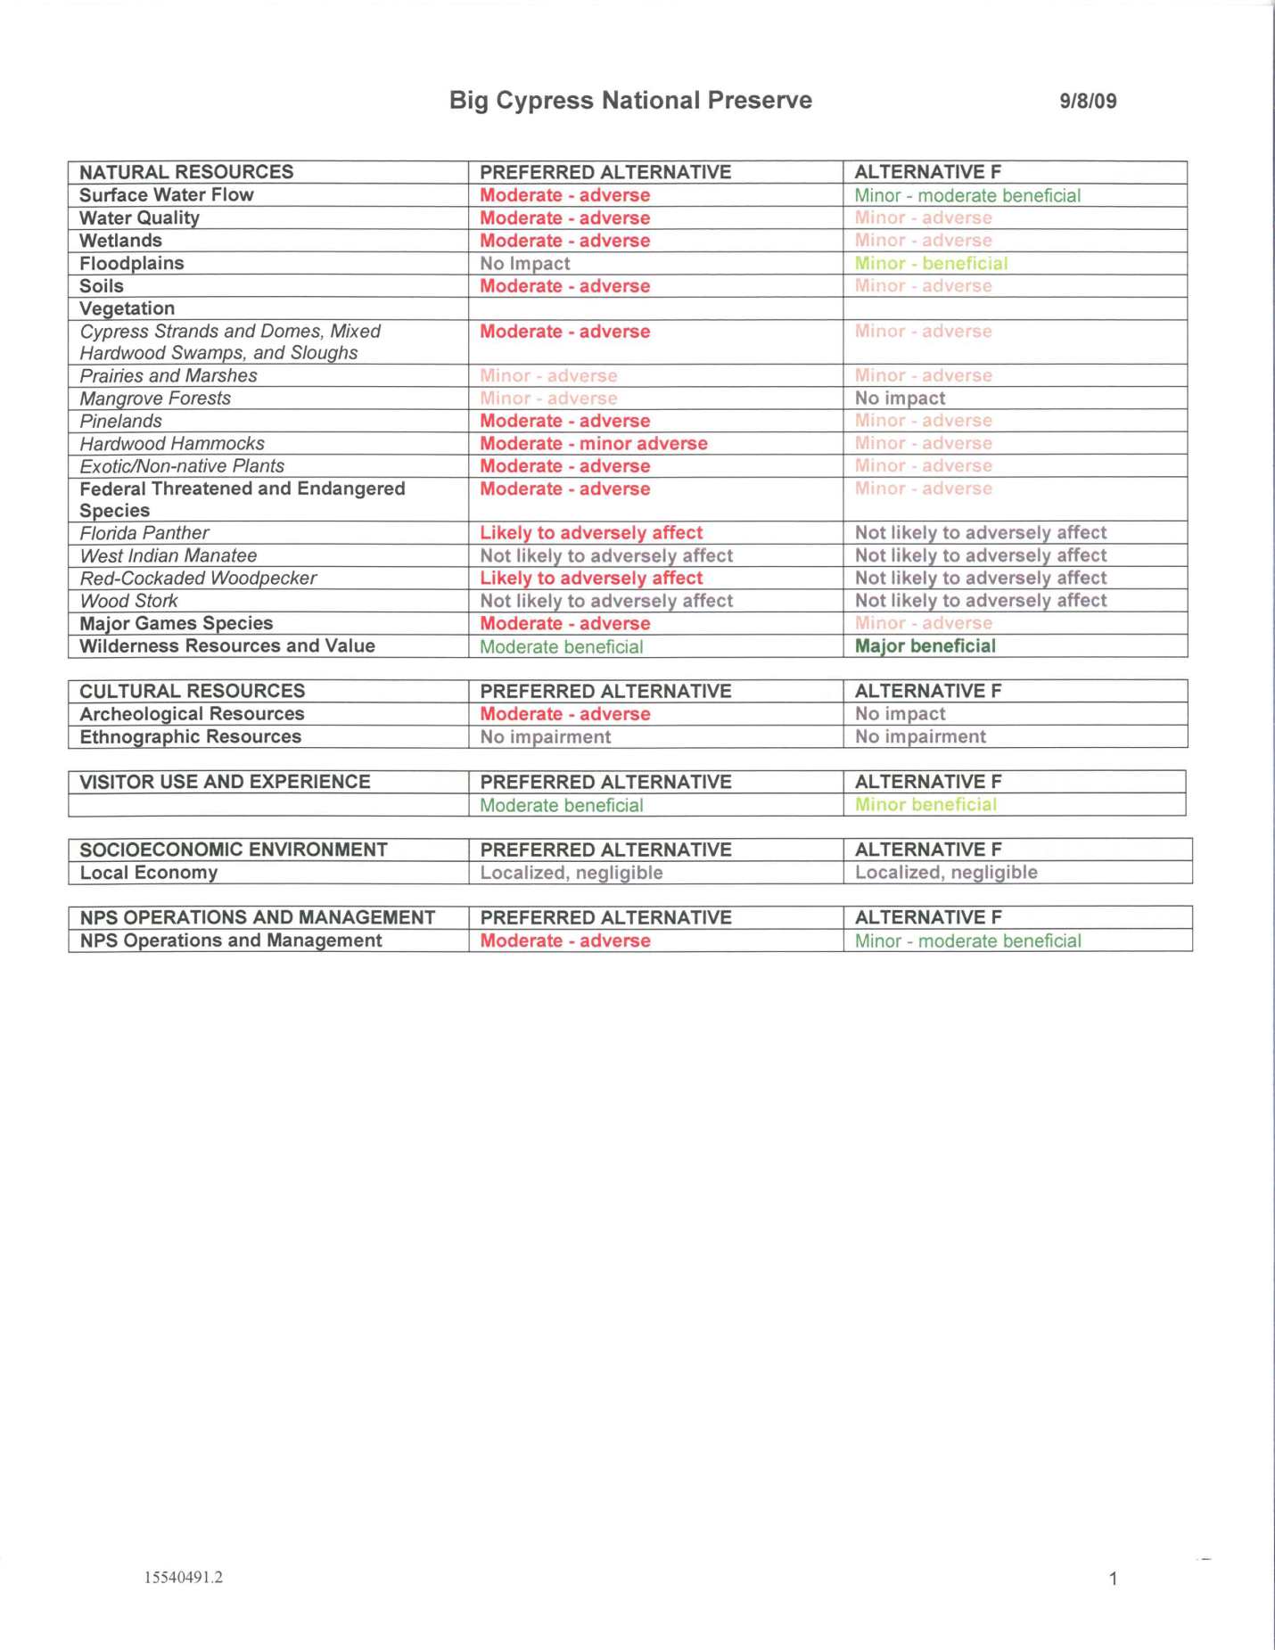

Big Cypress Butterflies  Prepared by Elane Nuehring 10/6/2009  Based on NABA Tri-County/Pinecrest Counts 2004-2009, NABA-Corkscrew Counts 1995-2007, Fakahatchee SP 1998-2008, Picayune SF 1998-2008, & Collier County butterfly list, www.butterfliesandmoths.org  & reviews by Mark Salvato, Linda Cooper, Marc Minno |  | KEY
Common Name | Scientific name | C=common (generally, or in appropriate habitat, or in appropriate season)  U=uncommon, occasional  R=rare  S=stray  X=extirpated in the park
SWALLOWTAILS | FAMILY PAPILIONIDAE;  SUBFAMILY PAPILIONINAE
Polydamus Swallowtail | Battus polydamus | R
Zebra Swallowtail | Eurytides marcellus | R
Black Swallowtail | Papilio polyxenes | R
Giant Swallowtail | Heraclides (Papilio) cresphontes | U
Eastern Tiger Swallowtail | Pterourus (Papilio) glaucus | C
Spicebush Swallowtail | Pterourus (Papilio) troilus | U to R
Palamedes Swallowtail | Pterourus (Papilio) palamedes | C
WHITES AND SULPHURS | FAMILY PIERIDAE
WHITES | SUBFAMILY PIERINAE
Florida White | Appias drusilla ??neumoegenii?? | R
Checkered White | Pontia protodice | U
Great Southern White | Ascia monuste | C
SULPHURS | SUBFAMILY COLIADINAE
Orange Sulphur | Colias eurytheme | R
Cloudless Sulphur | Phoebis sennae | C
Orange-barred Sulphur | Phoebis philea | R
Large Orange Sulphur | Phoebis agarithe | C
Barred Yellow | Eurema daira | C
Little Yellow | Eurema lisa | C
Sleepy Orange | Eurema nicippe | R
Dainty Sulphur | Nathalis iole | U
GOSSAMER-WINGS | FAMILY LYCAENIDAE
HAIRSTREAKS | SUBFAMILY THECLINAE
Silver-banded Hairstreak | Chlorostrymon simaethis | S-R
‘Southern’ Oak Hairstreak | Fixenia (Satyrium) favonius | R
White M Hairstreak | Parrhasius m-album | R
Gray Hairstreak | Strymon melinus | U
Mallow Scrub-Hairstreak | Strymon istapa | U
Fulvous Hairstreak | Electrostrymon angelia | R
Red-banded Hairstreak | Calycopis cecrops | C
Gray Ministreak | Ministrymon azia | R
BLUES | SUBFAMILY POLYOMMATINAE
Eastern Pygmy Blue | Brephidium isophthalma | C
Cassius Blue | Leptotes cassius | C
Ceraunus Blue | Hemiargus ceraunus | U
METALMARKS | FAMILY RIODINIDAE
Little Metalmark | Calephelis virginiensis | U
BRUSHFOOTS | FAMILY NYMPHALIDAE
HELICONIANS AND  FRITILLARIES | SUBFAMILY HELICONIINAE
Gulf Fritillary | Agraulis vanillae | C
Julia Heliconian | Dryas iulia | C
Zebra Heliconian | Heliconius charithonia | C
Variegated Fritillary | Euptoieta claudia | U-R
TRUE BRUSHFOOTS | SUBFAMILY NYMPHALINAE
Phaon Crescent | Phyciodes phaon | C
Pearl Crescent | Phyciodes tharos | C
American Lady | Vanessa virginiensis | R
Painted Lady | Vanessa cardui | R
Red Admiral | Vanessa atalanta | R
Common Buckeye | Junonia coenia | C
Mangrove Buckeye | Junonia evarete | R
Tropical Buckeye | Junonia genoveva | R
White Peacock | Anartia jatrophae | C
ADMIRALS AND  RELATIVES | SUBFAMILY LIMENITIDINAE
Viceroy | Limenitis archippus | C
Ruddy Daggerwing | Marpesia petreus | U
EMPERORS | SUBFAMILY APATURINAE
Hackberry Emperor | Asterocampa celtis | R
Tawny Emperor | Asterocampa clyton | R
SATYRS | SUBFAMILY SATYRINAE
Carolina Satyr | Hermeuptychia sosybius | R
Georgia Satyr | Neonympha areolata | C
MONARCHS | SUBFAMILY DANAINAE
Monarch | Danaus plexippus | R
Queen | Danaus gilippus | C
Soldier | Danaus eresimus | U
SKIPPERS | FAMILY HESPERIIDAE
SPREAD-WING SKIPPERS | SUBFAMILY PYRGINAE
Mangrove Skipper | Phocides pigmalion | U
Silver-spotted Skipper | Epargyreus clarus | R
Hammock Skipper | Polygonus leo | R
Long-tailed Skipper | Urbanus proteus | C
Dorantes Longtail | Urbanus dorantes | C
Northern Cloudywing | Thorybes pylades | U
Hayhurst’s Scallopwing | Staphylus hayhurstii | R
Juvenal’s Duskywing | Erynnis juvenalis | R
Horace’s Duskywing | Erynnis horatius | U
Zarucco Duskywing | Erynnis zarucco | R
Tropical Checkered-Skipper | Pyrgus oileus | C
Common/White Checkered- Skipper | Pyrgus communis/ albescens | R
GRASS-SKIPPERS | SUBFAMILY HESPERIIN AE
Swarthy Skipper | Nastra lherminier | R
Neamathla Skipper | Nastra neamathla | R
Three-spotted Skipper | Cymaenes tripunctus | R
Clouded Skipper | Lerema accius | C
Least Skipper | Ancyloxypha numitor | R
Southern Skipperling | Copaeodes minimus | U
Fiery Skipper | Hylephila phyleus | C
Baracoa Skipper | Polites baracoa | R
Whirlabout | Polites vibex | U
Southern Broken-Dash | Wallengrenia otho | U
Sachem | Atalopedes campestris | U
Delaware Skipper | Anatrytone logan | U
Aaron’s Skipper | Poanes aaroni | R
Palmetto Skipper | Euphyes arpa | R
Palatka Skipper | Euphyes pilatka | U
Berry’s Skipper | Euphyes berryi | R
Monk Skipper | Asbolis capucinus | U
Eufala Skipper | Lerodea eufala | U
Twin-spot Skipper | Oligoria maculata | C
Brazilian Skipper | Calpodes ethlius | C
Obscure Skipper | Panoquina panoquinoides | R
Ocola Skipper | Panoquina ocola | C

